System Specification:

Hardware Specification
S.N | Product | Company | Size | Type | Cost (Rs)
1 | Processor | Intel | --- | Intel Core i5-13400 | 20,000
2 | Motherboard | Asus | mATX | Prime B660M-A | 17,000
3 | Hard Drive | Samsung | 500 GB | 870 EVO SSD | 8,000
4 | Power Supply Unit | Corsair | --- | CV650 650 Watt | 6,500
5 | RAM | Kingston | 16 GB | Fury Beast DDR4 SDRAM | 8,000
6 | Graphics Card | NVIDIA | 4 GB | GeForce GTX 1650 PCI-Express | 28,000
7 | Sound Card | Asus | --- | Xonar SE | 1,500
8 | Network Card | TP-Link | --- | AC600 Wi-Fi PCIe Adapter | 2,000
9 | Heat Sink and Fan | Cooler Master | --- | Hyper 212 Black Edition | 3,000
10 | Monitor | Dell | 24 inch | Full HD IPS | 20,000
11 | Printer | Canon | --- | PIXMA G2020 Wireless | 15,000
12 | Mouse | Logitech | --- | M185 Optical | 800
13 | Keyboard | Logitech | --- | K120 | 1,200
14 | Digital Camera | Nikon | --- | Coolpix B500 Digital | 40,000
15 | Scanner | Brother | --- | DS-620 Portable | 9,000
16 | Optical Media | Verbatim | 4.7 GB | DVD-RW / Blu-ray Writer | 3,000
17 | Portable Drive | Seagate | 1 TB | Portable Hard Drive | 8,000

Software Specification
S.N | Product | Brand | Version
1 | Adobe Photoshop | Adobe | CC 2026
2 | Adobe Premiere Pro | Adobe | CC 2026
3 | Microsoft Office | Microsoft | 365
4 | Antivirus | Bitdefender | Total Security 2026
5 | VLC Media Player | VideoLAN | 3.0.x
6 | Operating System | Microsoft | Windows 11 Pro (64-bit)

Network Components
S.N | Component | Product / Service | Description
1 | Ethernet Connectivity | Gigabit Ethernet (RJ-45, Cat6 cable) | Wired connection for fast, stable transfer of large media files
2 | Wireless Connectivity | Wi-Fi 6 (802.11ax) | High-speed wireless access for mobility and secondary devices
3 | Network Storage | Synology DS220+ NAS (4 TB) | Centralised backing store for project files, accessible on the network
4 | Network Security | Firewall + WPA3 encryption | Protects the system and stored media from unauthorised access
5 | Backup Solution | Cloud Backup (Backblaze) + local NAS | Automated off-site and on-site backup of finished and in-progress work

Hardware Justification:

Processor: Intel Core i5-13400
A mid-range CPU that multitasks well across Photoshop, video editing and Office, without the cost of a flagship chip.

Heat Sink and Fan: Cooler Master Hyper 212
A cost-effective air cooler that keeps the i5-13400 stable during long editing sessions, well suited to a processor that doesn't run extremely hot.

Motherboard: Asus Prime B660M-A
A B660 board that supports current Intel CPUs and DDR4 RAM with enough PCIe slots for the graphics, sound and network cards, at a fraction of a gaming board's price.

Hard Drive: Samsung 870 EVO SSD (500 GB)
An SSD keeps programs and active files loading quickly; capacity is kept modest since the portable drive handles bulk storage.

Power Supply Unit: Corsair CV650 (650W)
650 watts comfortably powers the mid-range build without paying for unused headroom.

RAM: Kingston Fury Beast 16 GB DDR4
16 GB is enough to run Photoshop, a video editor and Office together, and DDR4 costs much less than DDR5.

Graphics Card: NVIDIA GeForce GTX 1650 (4 GB)
An affordable dedicated GPU that still accelerates Photoshop and video work, without flagship gaming-card pricing.

Sound Card: Asus Xonar SE
A budget dedicated sound card that improves clarity and latency over onboard audio for reviewing and mixing sound.

Network Card: TP-Link AC600 Wi-Fi Adapter
A basic dual-band adapter gives reliable wireless access at a fraction of the cost of Wi-Fi 6 hardware.

Monitor: Dell 24" Full HD IPS
An IPS panel gives accurate colour for editing; Full HD keeps cost well below a 4K display.

Printer: Canon PIXMA G2020
A wireless, refillable-ink printer for low-cost colour proofing of posters and graphics.

Mouse: Logitech M185
A reliable wireless optical mouse for everyday editing work at low cost.

Keyboard: Logitech K120
A simple, durable wired keyboard that covers daily typing and shortcut use at minimal cost.

Digital Camera: Nikon Coolpix B500
A strong zoom range and good HD stills/video at a fraction of a mirrorless camera's price.

Scanner: Brother DS-620
A compact, affordable scanner for digitising photos and documents on the go.

Optical Media: DVD-RW / Blu-ray Writer
An inexpensive way to archive or hand off finished projects on physical disc.

Portable Drive: Seagate 1 TB Portable Hard Drive
Generous, low-cost bulk storage for Baneed's growing image and video library.

Software Justification

Adobe Photoshop CC
Industry-standard image editing and design tool, directly meeting Baneed's stated need.

Adobe Premiere Pro CC
Professional timeline-based video editing for Baneed's film-making work.

Microsoft Office 365
Covers everyday documentation, proposals and client presentations.

Antivirus: Bitdefender Total Security
Real-time protection against viruses and phishing while regularly connected online.

VLC Media Player
Free, lightweight player for quickly previewing footage in almost any format.

Operating System: Windows 11 Pro (64-bit)
Broad software compatibility, strong built-in security and solid multitasking support.

Network Component Justification:

Ethernet Connectivity
Wired Gigabit Ethernet gives the fastest, most stable link for large file transfers.

Wireless Connectivity
Wi-Fi 6 offers flexible, strong-throughput access from anywhere in the office.

Network Storage
A NAS device gives a central pool of storage beyond the local drive, shareable across devices.

Network Security
A firewall plus WPA3 encryption protects the system and client media from unauthorised access.

Backup Solution
Local NAS plus off-site cloud backup protects Baneed's work from loss or hardware failure.

PROCEDURE:

IPCONFIG

IP commands:

Ipconfig
Displays detailed network configuration information for all adapters, including the physical (MAC) address, DHCP status, and the DNS servers in use.
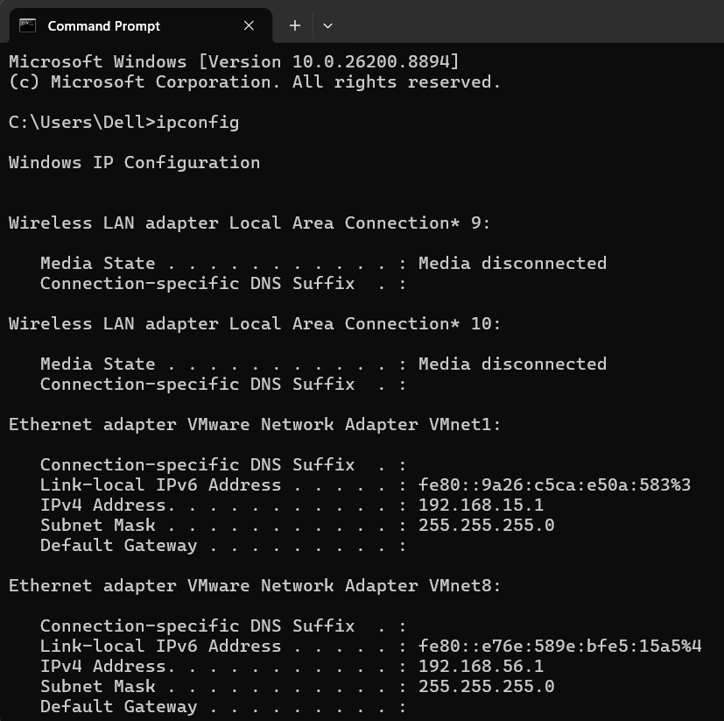

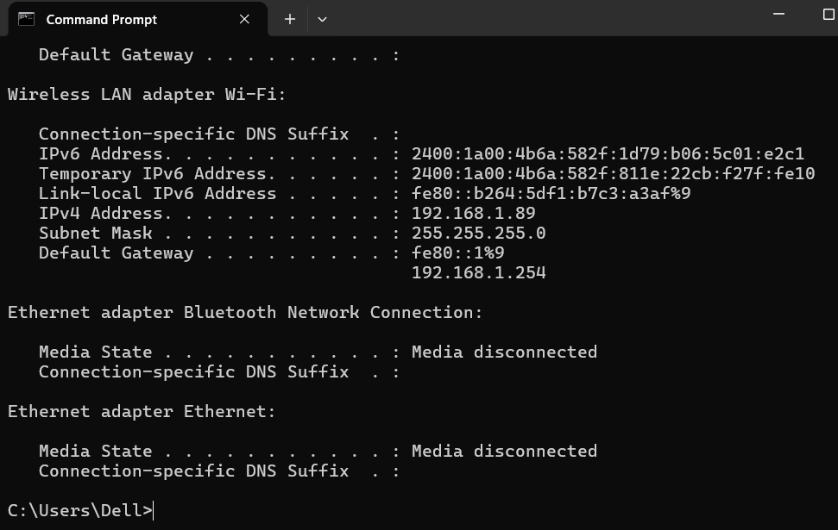

ipconfig /all
Displays detailed network configuration information for all adapters, including the physical (MAC) address, DHCP status, and the DNS servers in use.
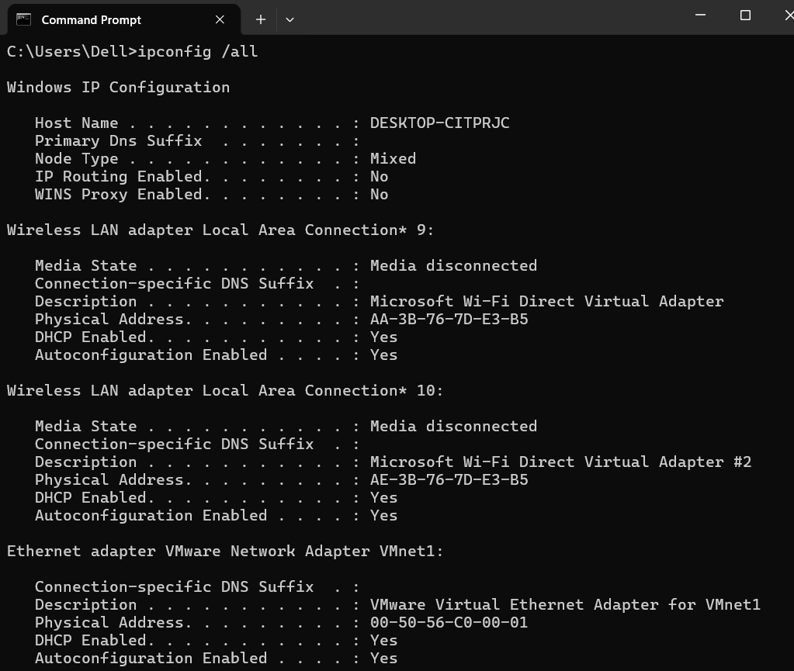

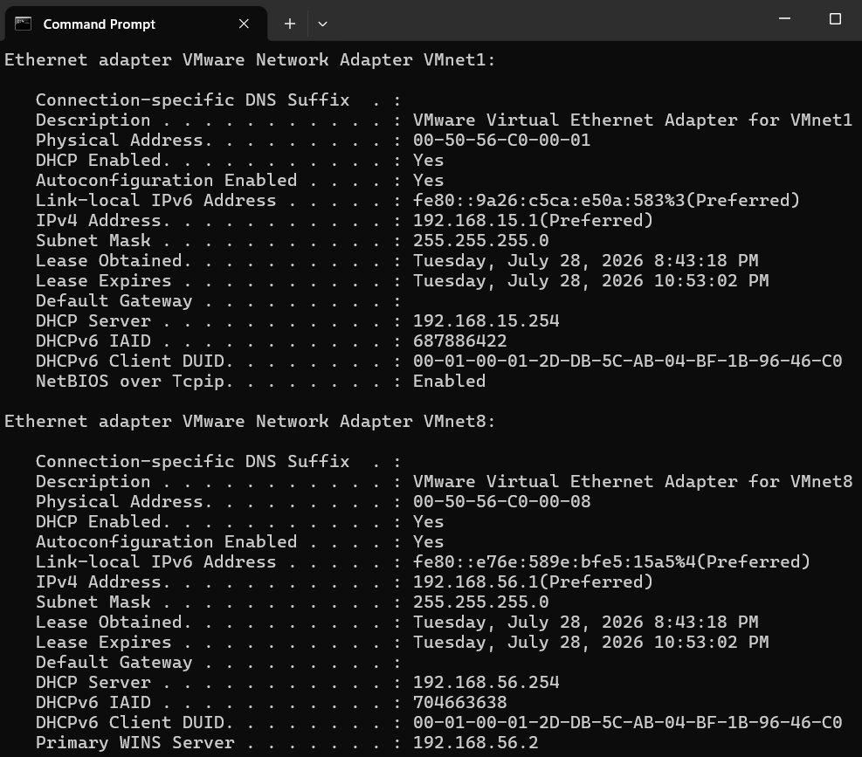

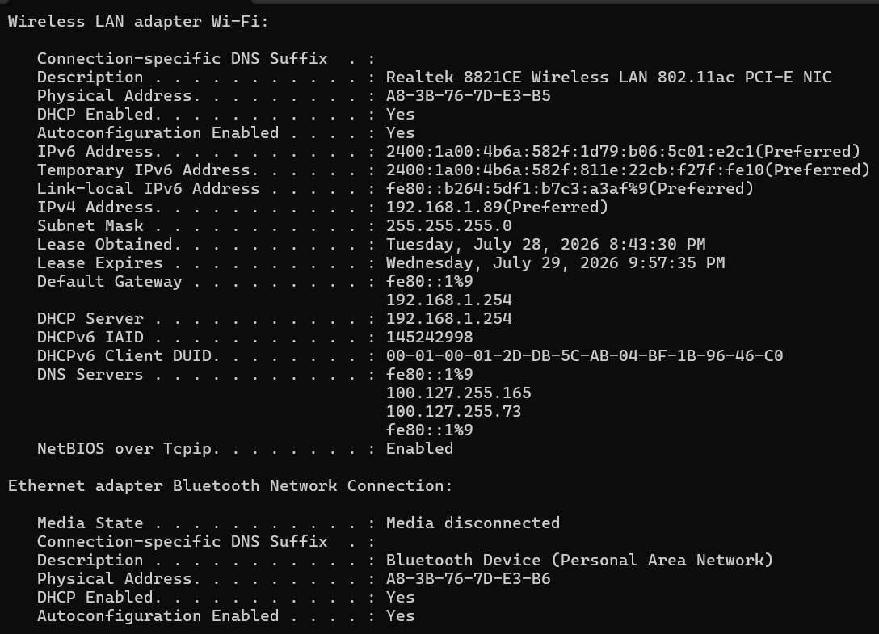

- ipconfig /release
Release the current IP address assigned by the DHCP server, leaving the adapter without a usable address until a new one is obtained.
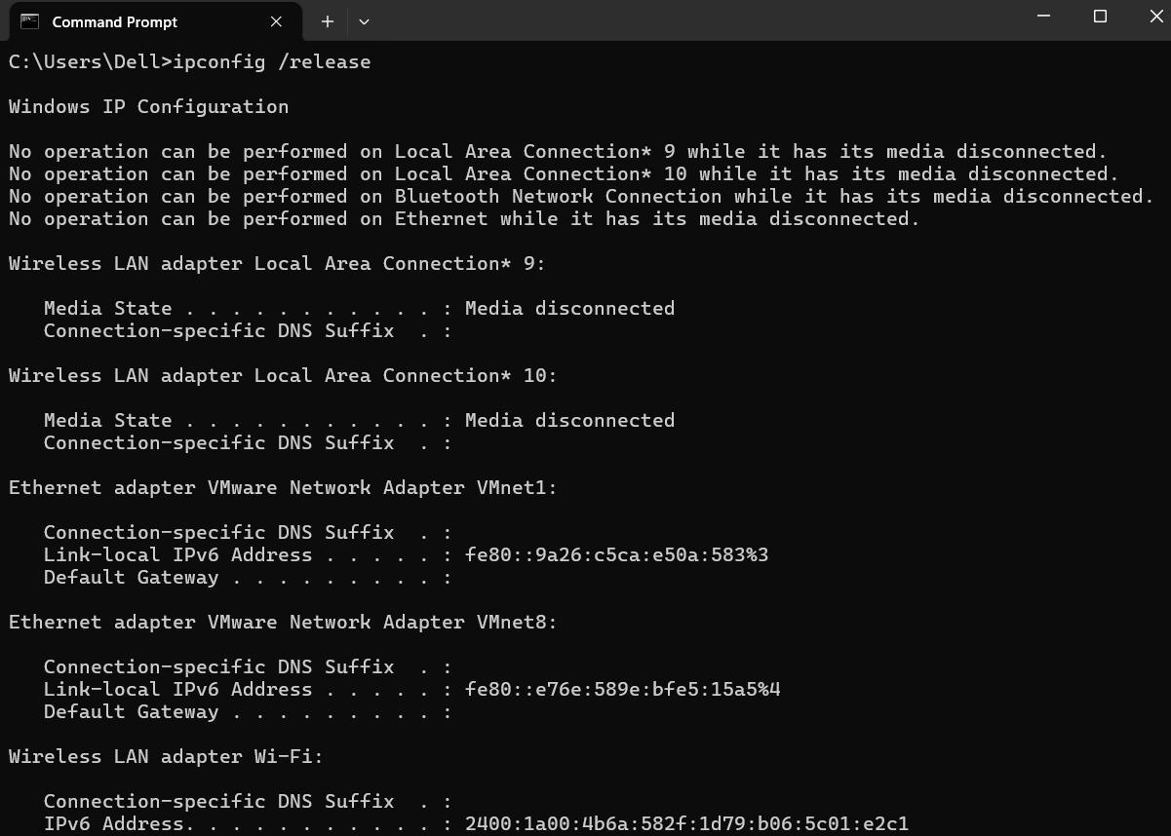

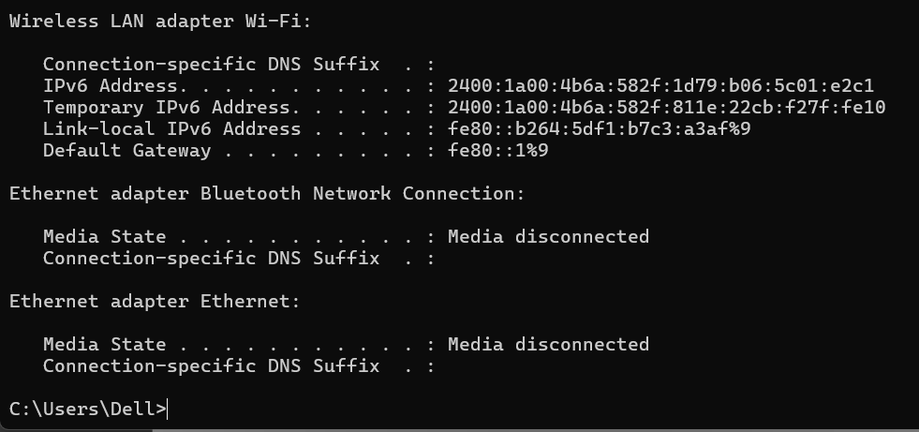

- ipconfig /renew
Requests a new IP address from the DHCP server, restoring network connectivity after a release (or refreshing the current lease).
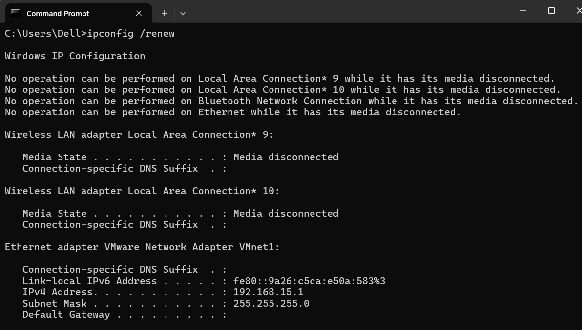

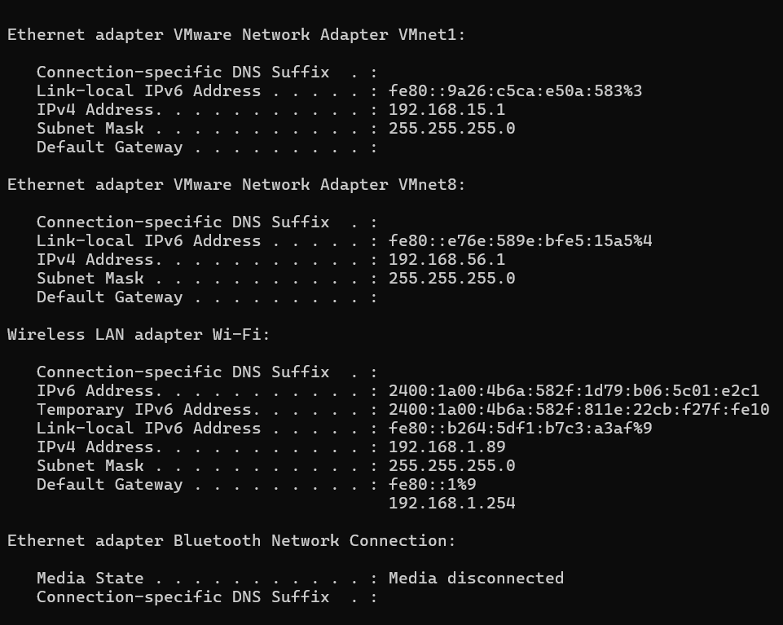

- ipconfig /flushdns

Clears the DNS resolver cache, forcing the computer to look up domain names again rather than using stored (and possibly outdated) results.
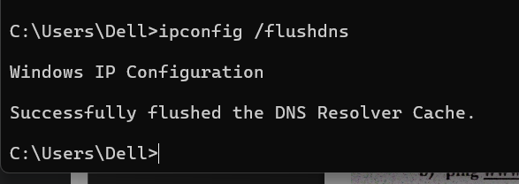

- PING

PING commands:

- ping www.google.com
Sends four ICMP echo requests to www.google.com to test basic connectivity.
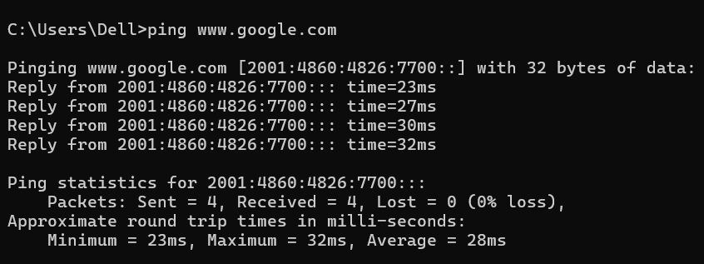

- ping www.google.com -t
Sends ICMP echo requests continuously to www.google.com until the command is manually stopped with Ctrl + C, useful for monitoring a connection over time.
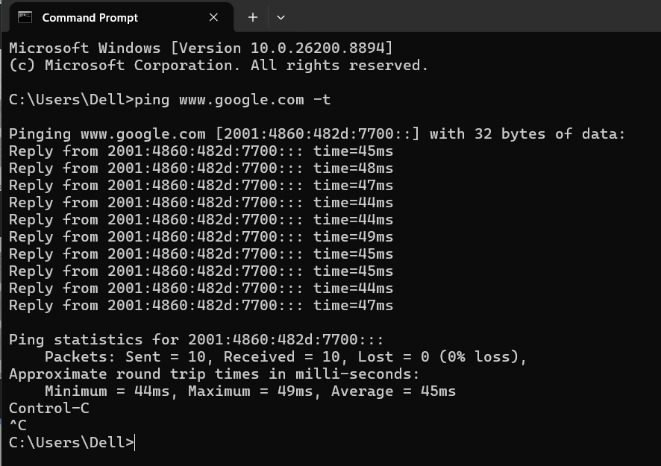

- ping www.google.com -t -l 1400
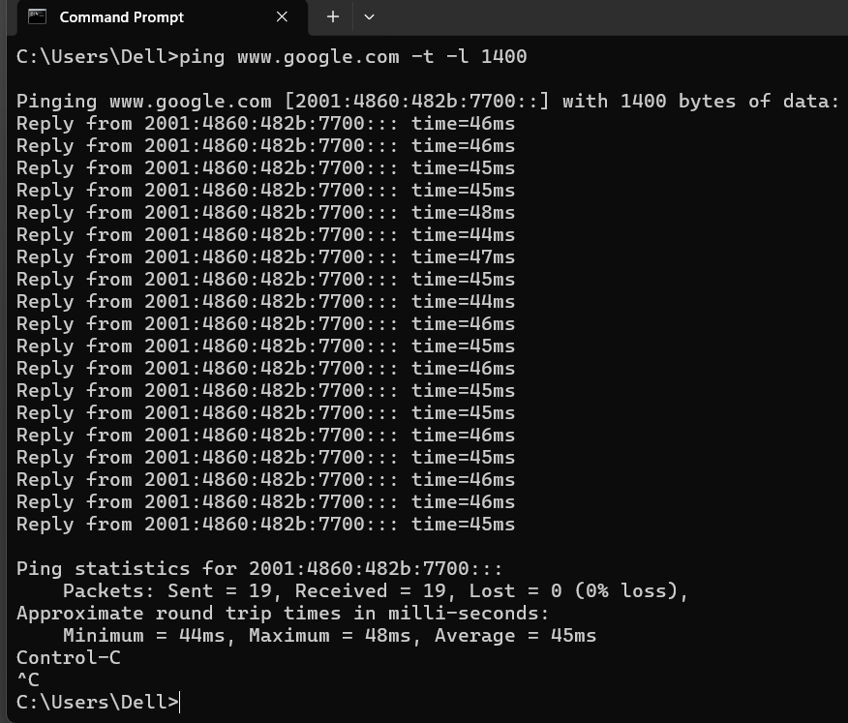
Sends continuous ICMP echo requests using a larger, custom packet size of 1400 bytes instead of the default 32 bytes, which can help reveal issues that only appear with larger packets, such as fragmentation.

- NSLOOKUP

NSLOOKUP commands:

nslookup google.com
Queries the configured DNS server to retrieve the IP address(es) associated with the domain name google.com.
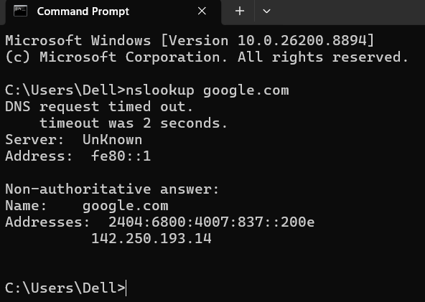

- TRACEROUTE

- tracert www.google.com
Traces the route packets take to reach www.google.com, displaying each hop along the path with its IP address (and hostname, where available) and response time.
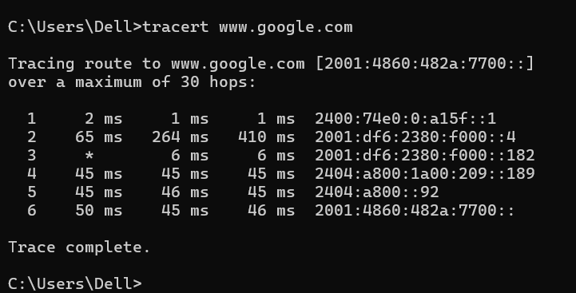

- tracert -d google.com
Performs the same route tracing but skips resolving IP addresses to hostnames, which speeds up the process.
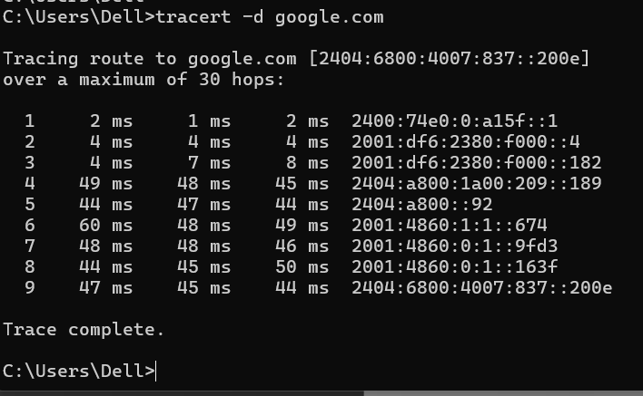

- NETSTAT

NETSTAT command:

- netstat -an
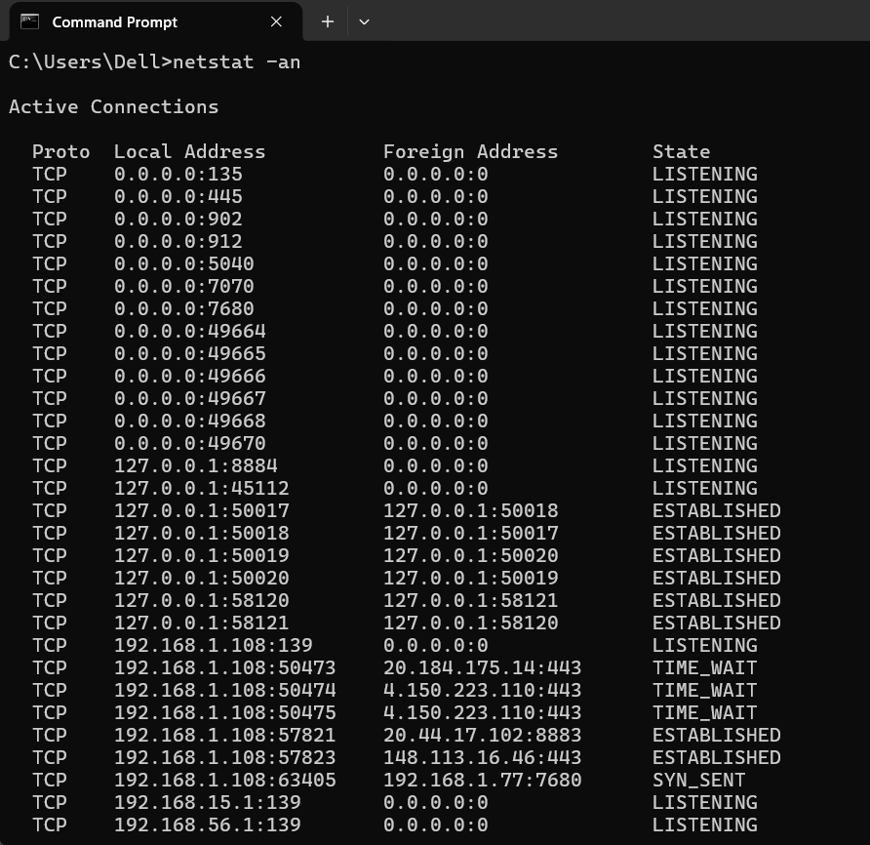
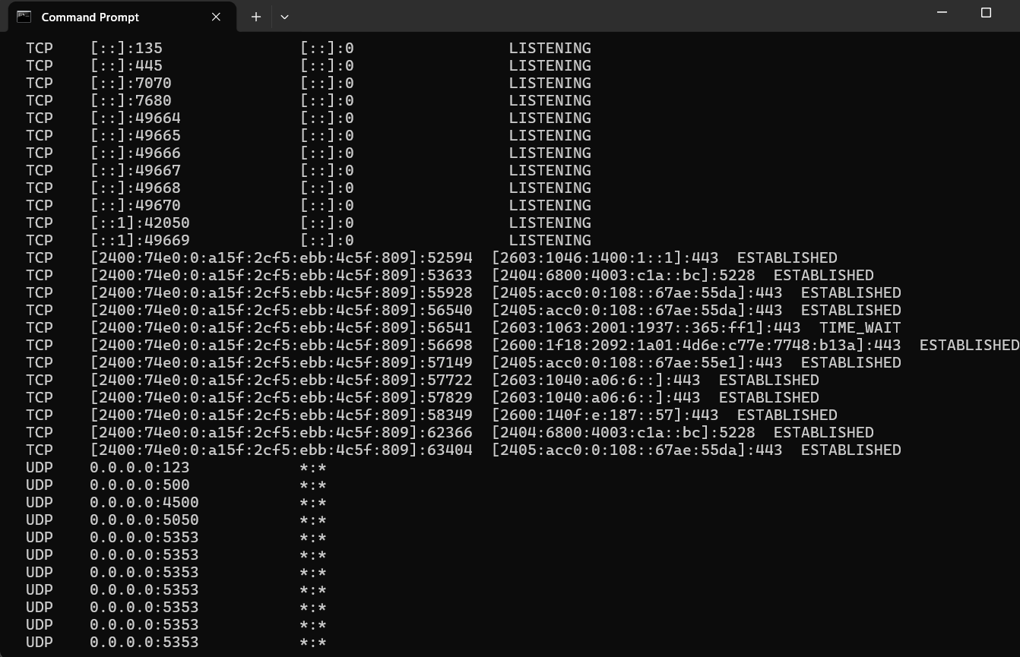
Displays all active network connections and listening ports, with IP addresses and port numbers shown in numerical form rather than resolved names.

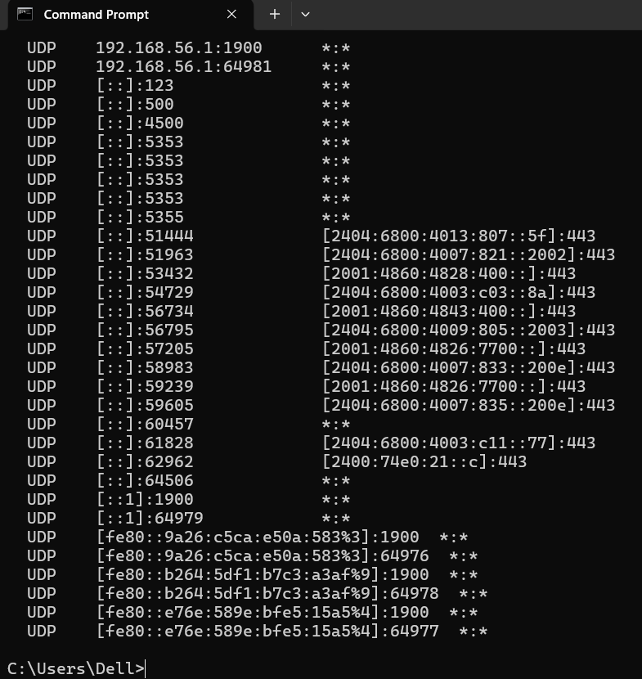

CONCLUSION:
This lab introduced five essential command-line networking tools. IPCONFIG shows and manages the local computer's IP configuration; PING tests basic connectivity and measures response time to a destination; NSLOOKUP checks that domain names resolve correctly through DNS; TRACERT reveals the path and timing of each hop between the local computer and a destination; and NETSTAT shows which network connections and ports are currently active on the computer. Together, these tools form the standard first line of diagnosis for most everyday network problems, from a computer failing to obtain an address, to a website not loading, to a connection that has slowed down somewhere along its route.

Lab 4

PROCEDURE

- Capture Live Network Traffic

Goal: Learn to start/stop capturing packets.
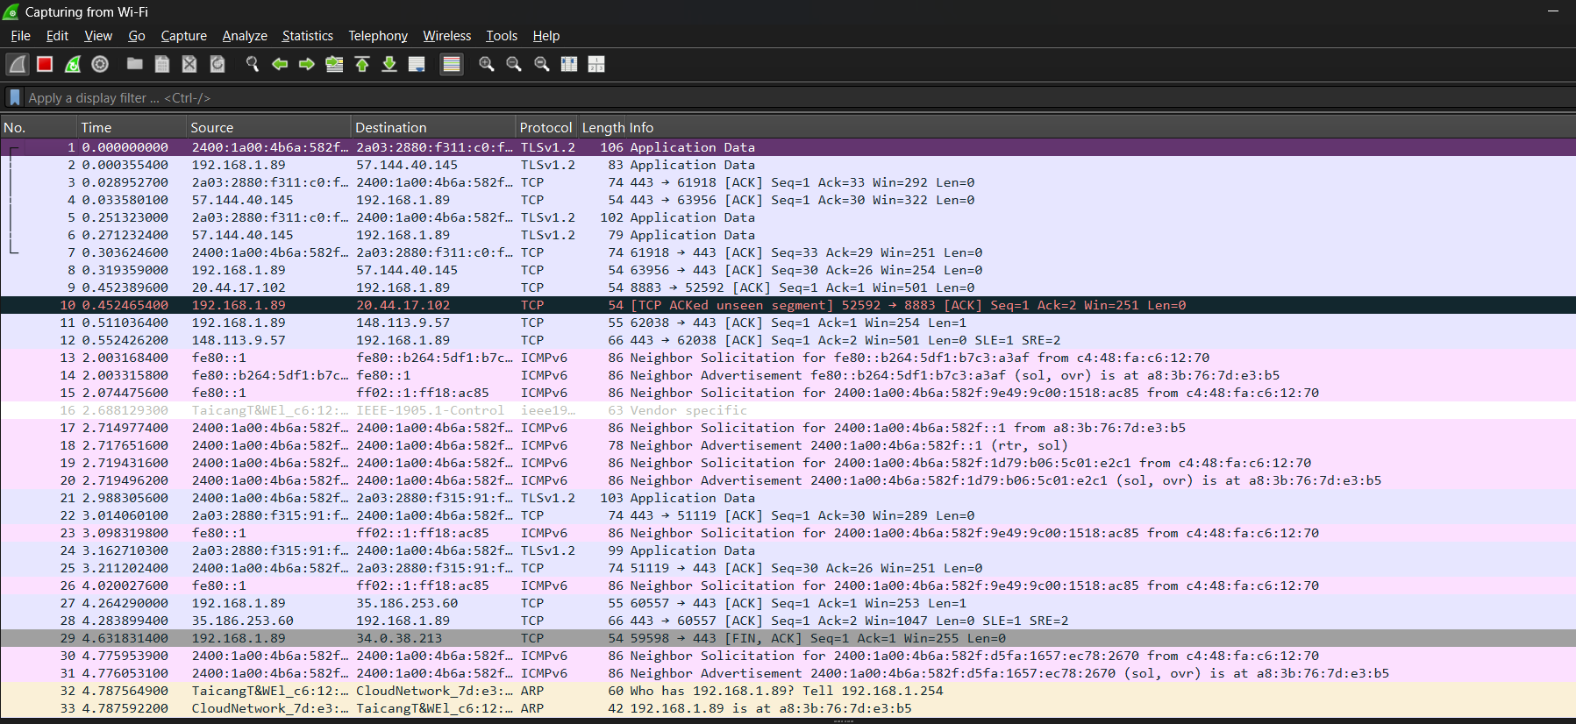

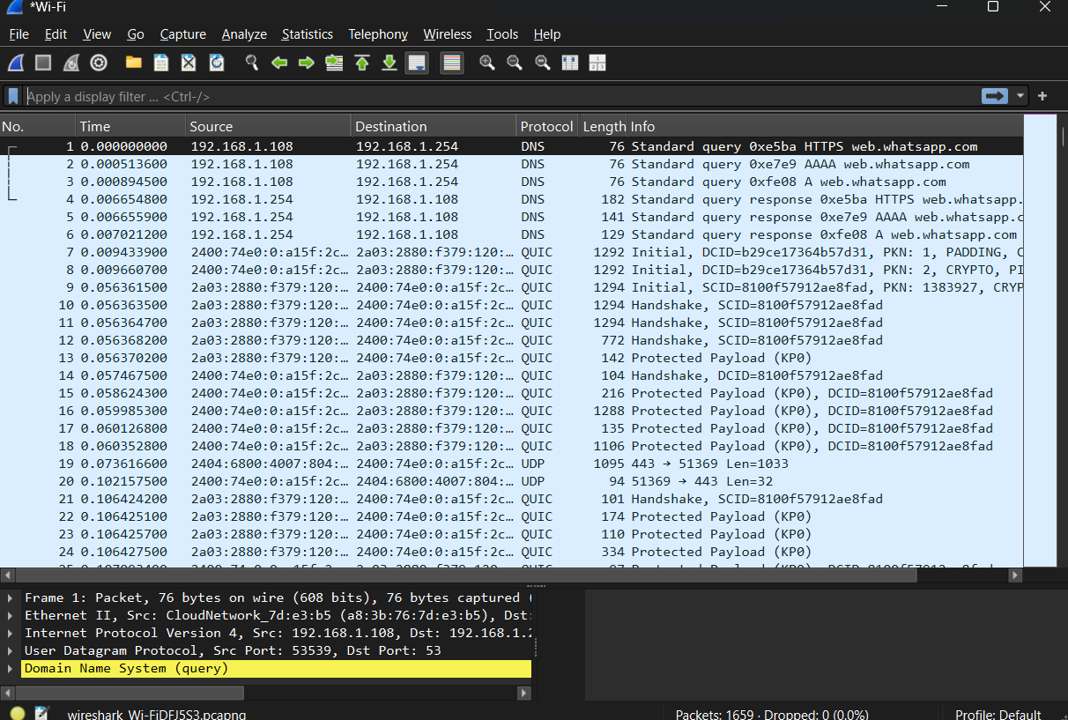

2. Analyze DNS Queries

Goal: Understand how domain names resolve.
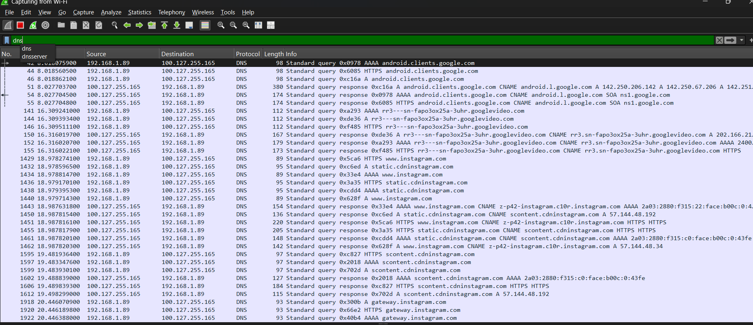

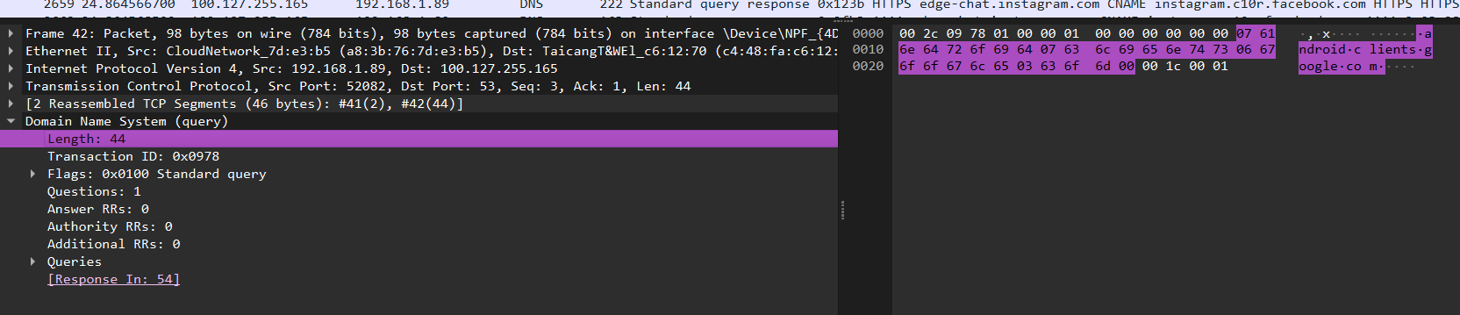

3. Observe TCP 3-Way Handshake

Goal: See how TCP connections are established.
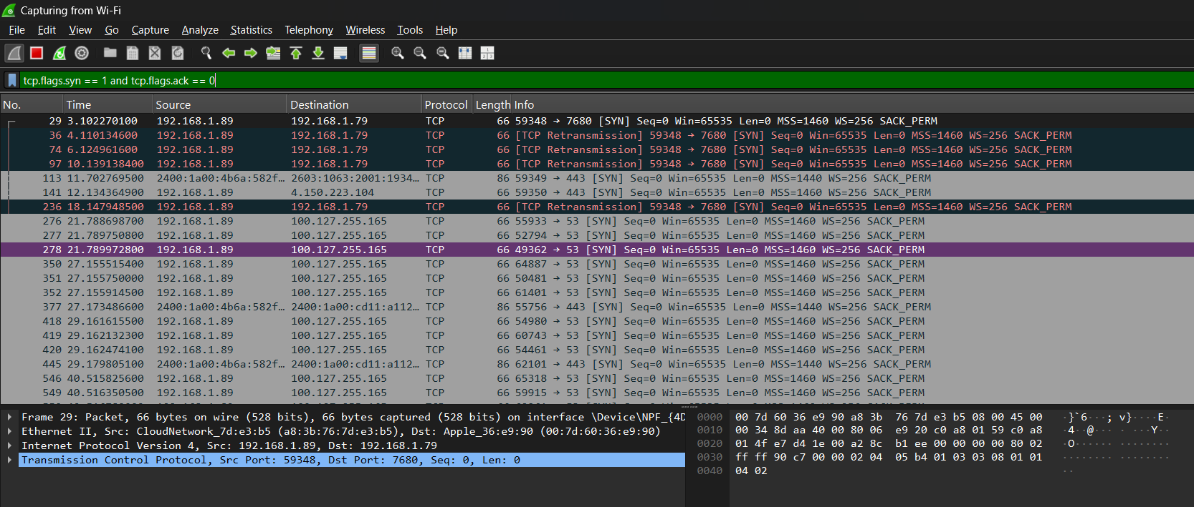

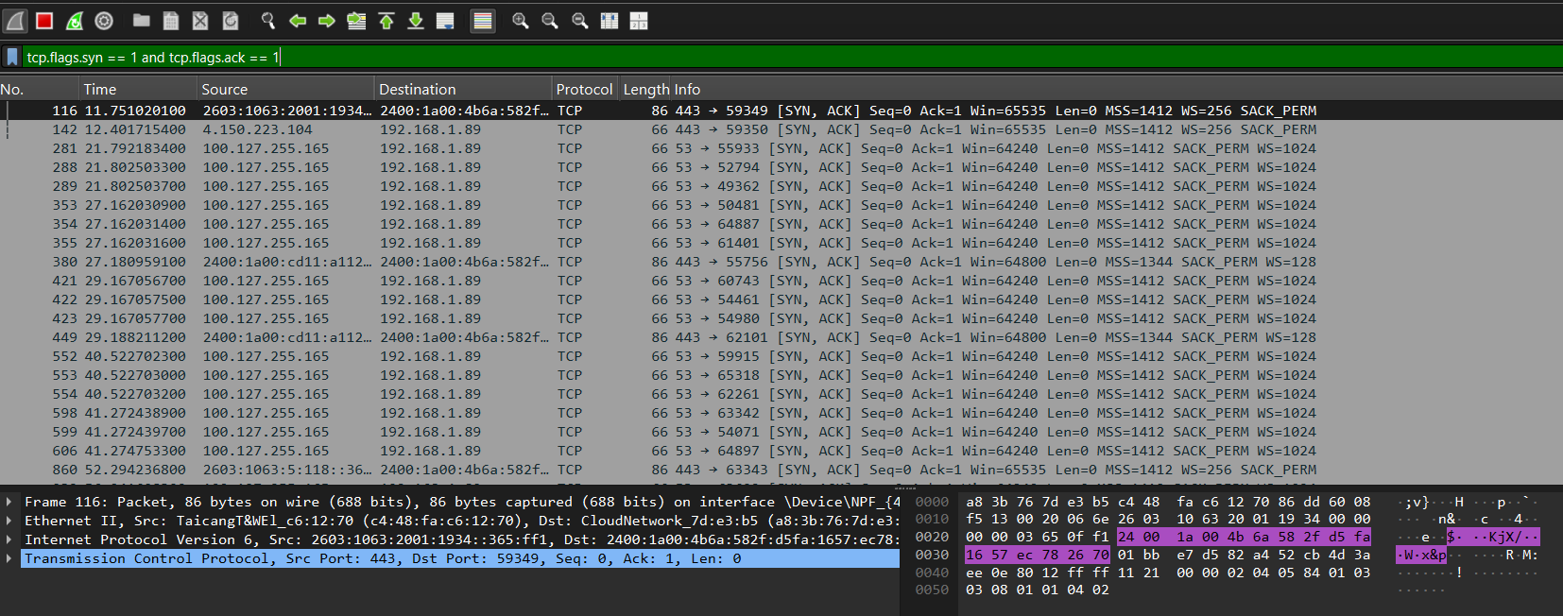

4. Capture ICMP Ping Packets

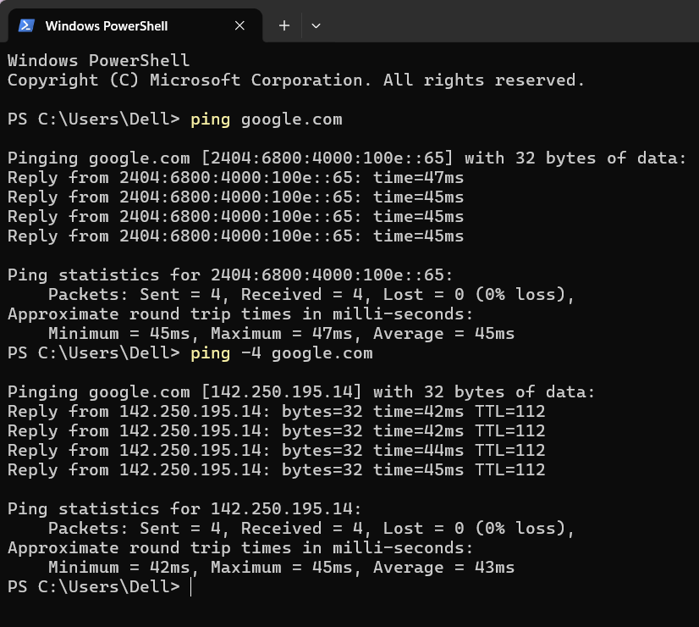
Goal: See how Ping works at the packet level.

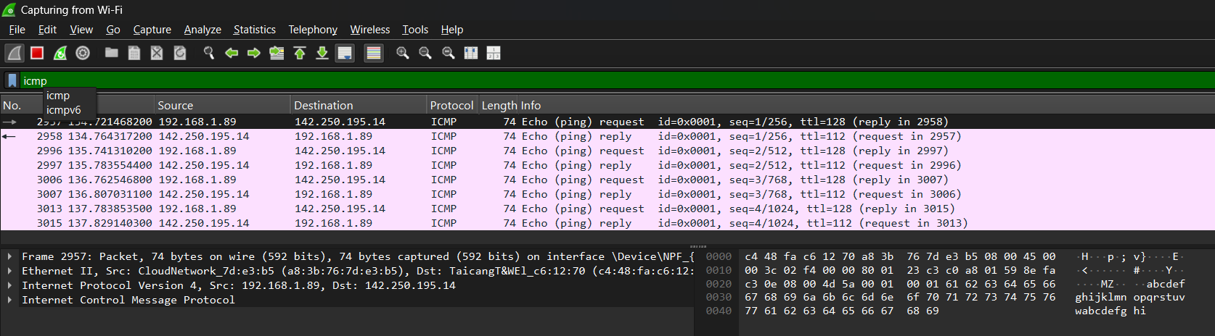

Conclusion:

This lab introduced the basics of packet analysis using Wireshark. We learned to capture network traffic, analyze DNS, TCP, and ICMP packets, and understand how network communication works. Overall, this lab enhanced our understanding of network communication, packet analysis, and the role of Wireshark as an essential tool for network troubleshooting and security analysis.

Lab 5

Procedure
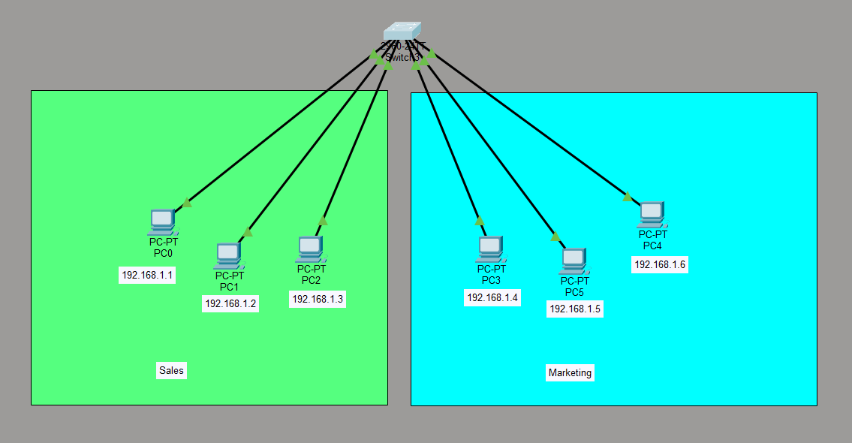

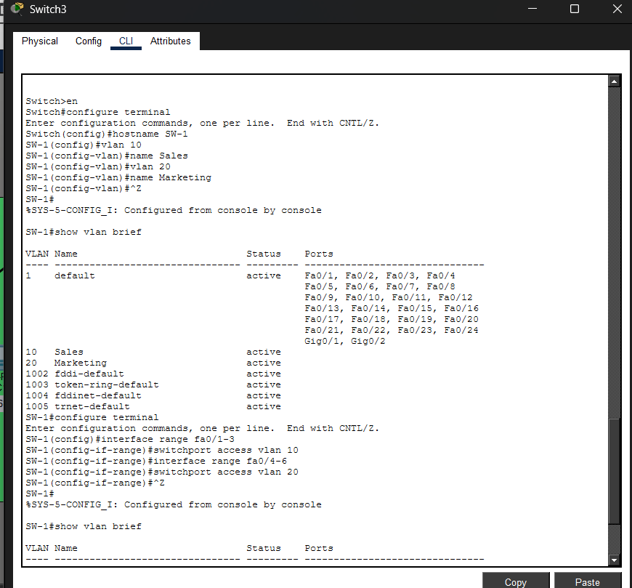

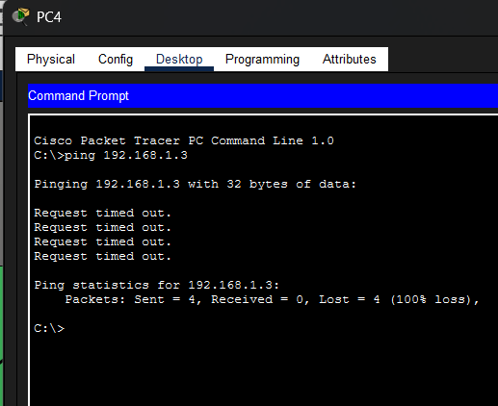
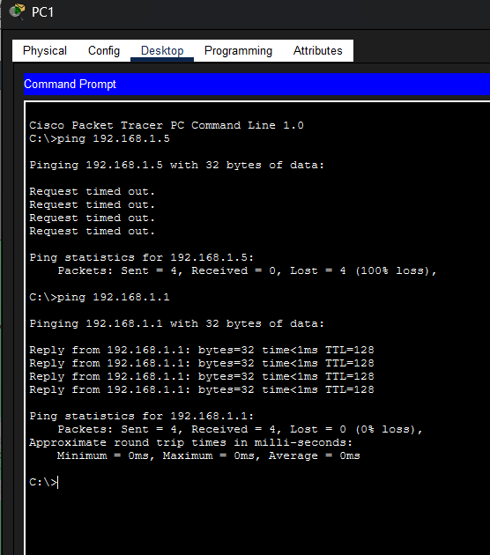
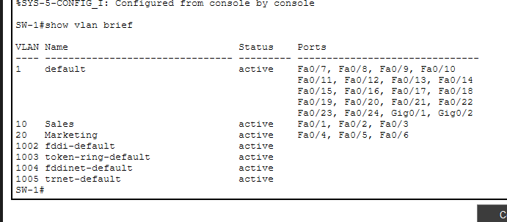
Lab 5

CONCLUSION:

In this lab, a simple VLAN configuration was successfully implemented using a Cisco switch in Cisco Packet Tracer. Two VLANs were created for the Sales (VLAN 10) and Marketing (VLAN 20) departments, with two PCs assigned to each VLAN. The switch ports were configured as access ports and assigned to their respective VLANs. The show vlan brief command verified that the VLANs and port assignments were correct. When a ping was performed between a PC in the Sales VLAN and a PC in the Marketing VLAN, communication failed because devices in different VLANs cannot communicate without inter-VLAN routing. This lab demonstrated how VLANs logically divide a network, improve security, reduce broadcast traffic, and simplify network management.

Lab 6

Procedure
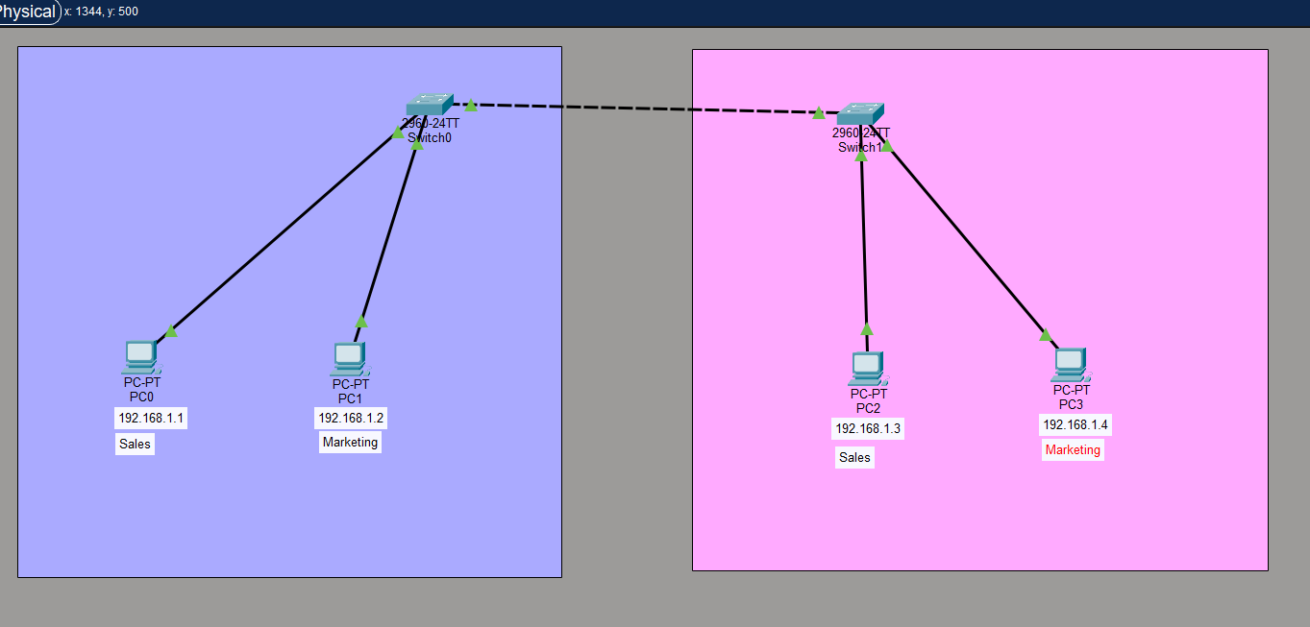

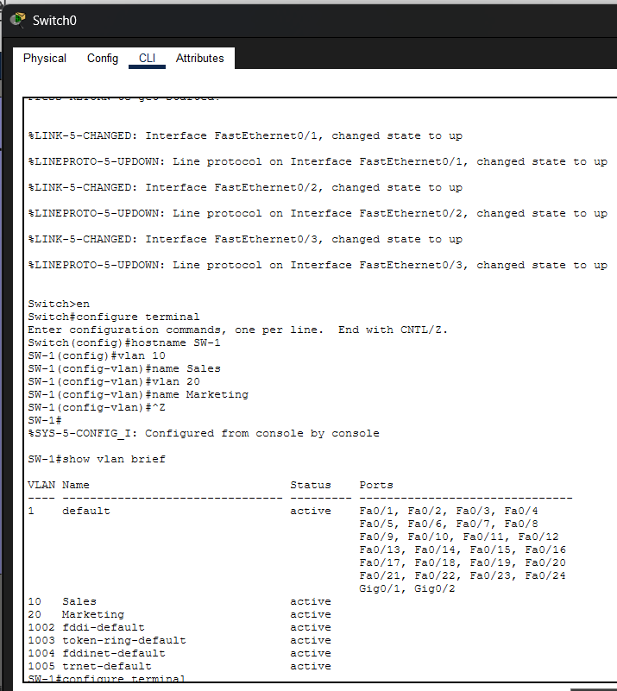

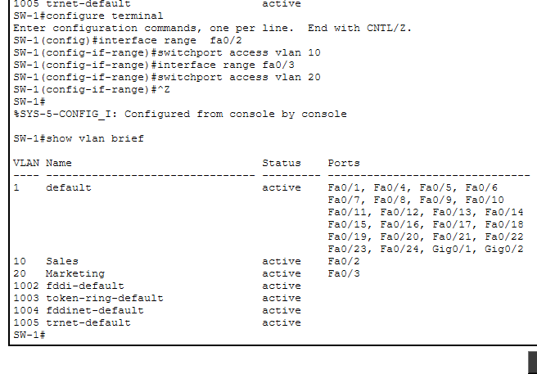
Lab 6

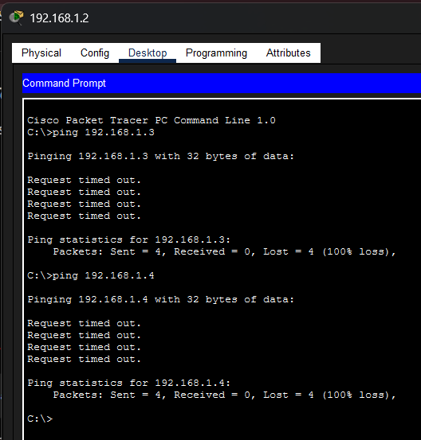
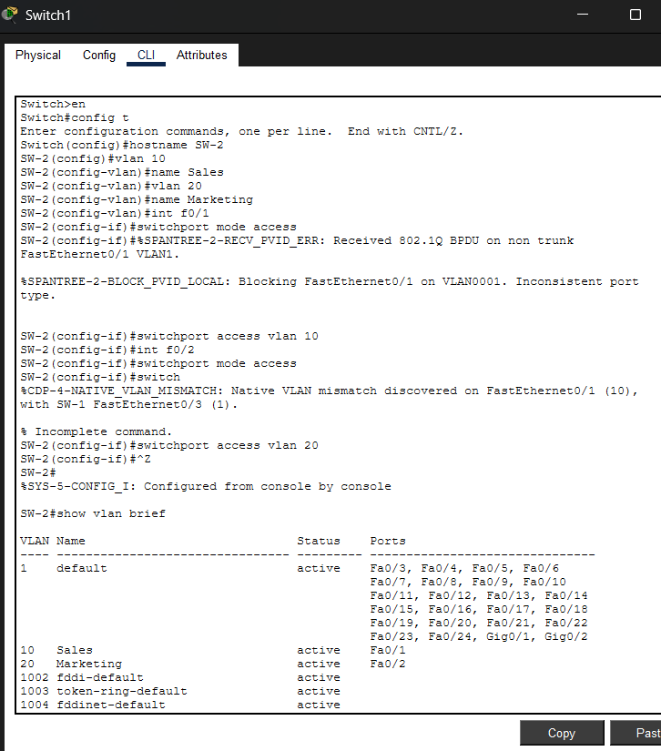

CONCLUSION:

This lab successfully demonstrated the configuration of VLANs and trunk links using Cisco Packet Tracer. Two VLANs, Sales and Marketing, were created on two switches, and a trunk port was configured to carry VLAN traffic between them. Communication between devices in the same VLAN across different switches was successful, proving that the trunk link was working correctly. However, communication between different VLANs failed because inter-VLAN routing was not configured. This lab highlighted the importance of VLAN segmentation, trunking, and the role of Layer 3 routing in enabling communication between different VLANs.

Lab 7

Procedure:

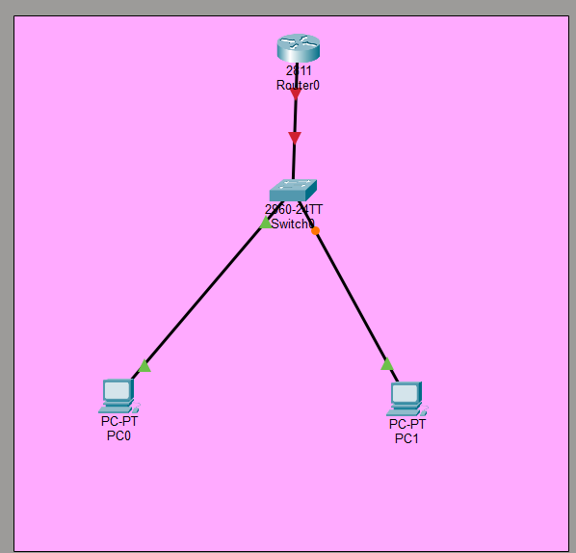
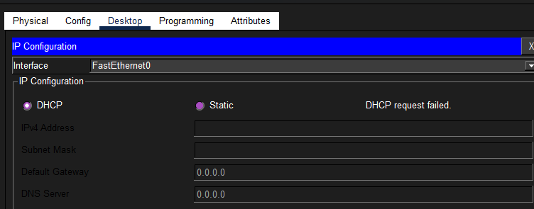

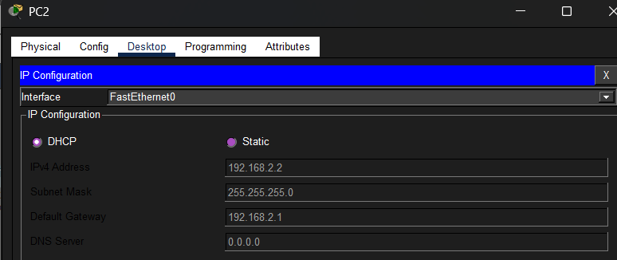

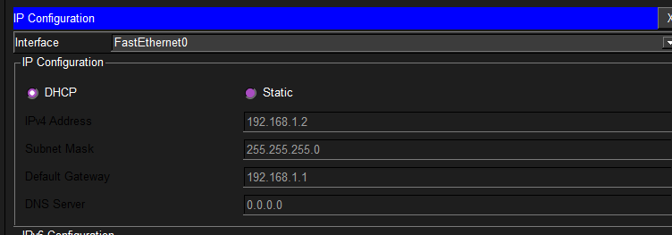

CONCLUSION:

In this lab, a Cisco router was configured to function as a DHCP server, enabling automatic IP address assignment to multiple client devices. All PCs successfully obtained their network configuration from the DHCP pool without requiring manual IP configuration. This demonstrated the advantages of DHCP in reducing administrative effort, minimizing configuration errors, and simplifying network management in LAN environments.

Lab 8

Procedure:
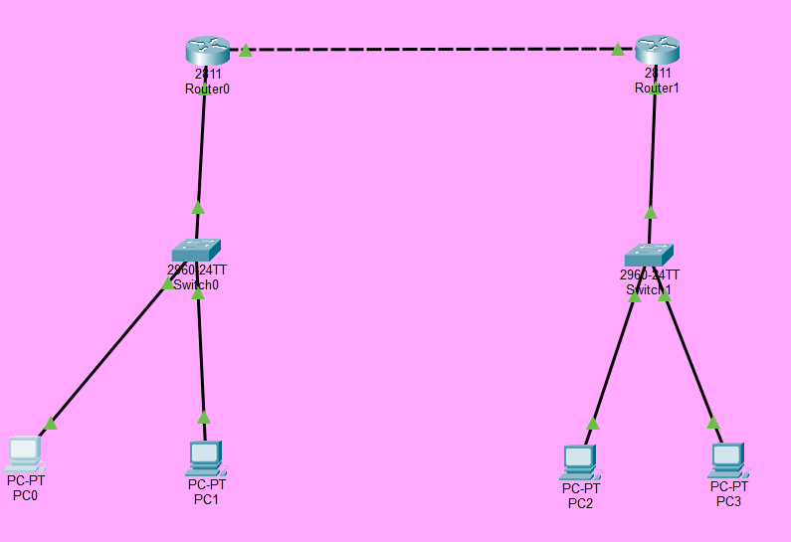

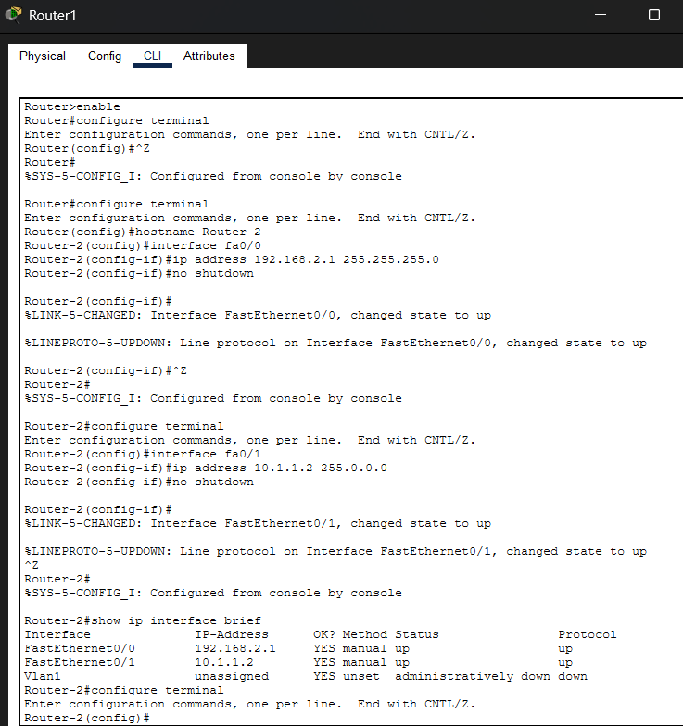
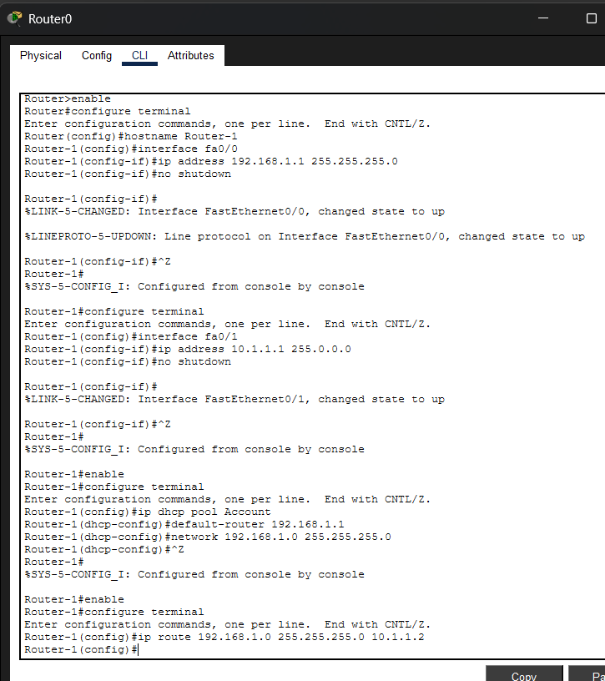

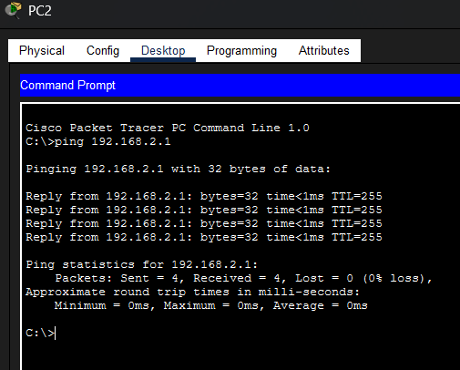
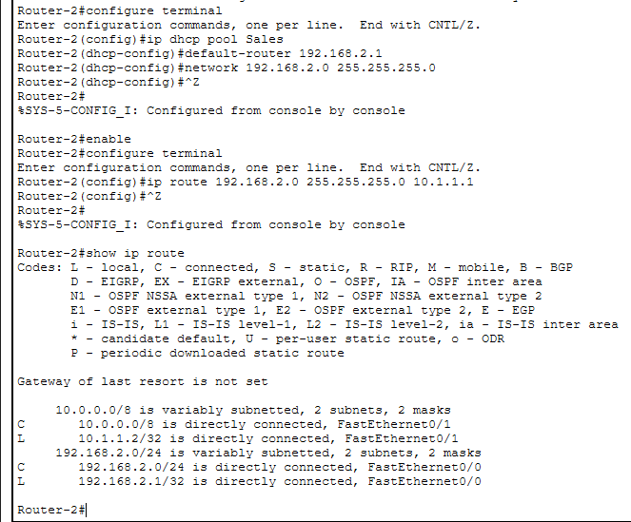

CONCLUSION:

In this lab, two routers were configured with static routes to enable communication between two separate LANs. After assigning IP addresses to router interfaces and configuring the appropriate static routes, devices on different networks were able to exchange data successfully. This lab demonstrated how static routing manually directs traffic between networks and highlighted its simplicity and effectiveness in small network environments.

Lab 9

Procedure:
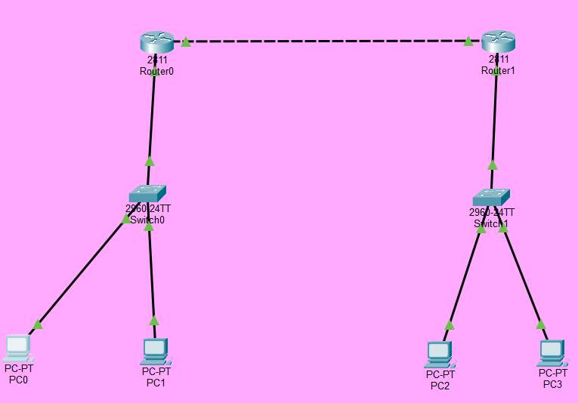

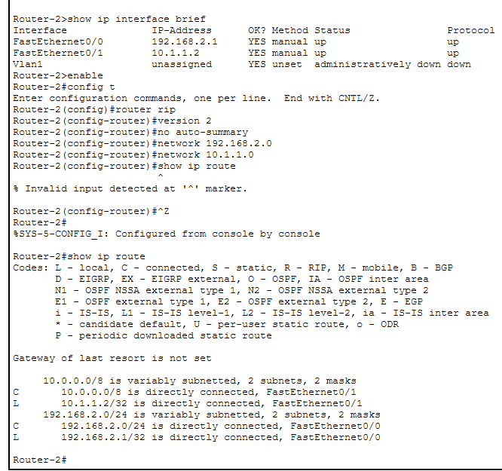

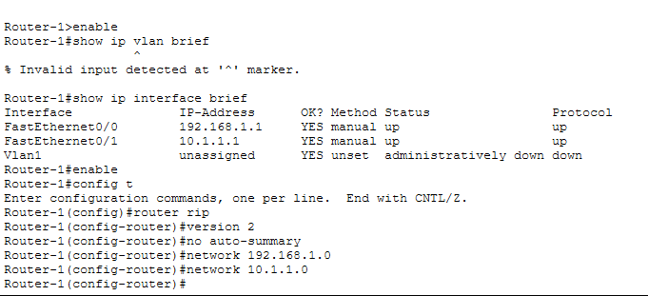

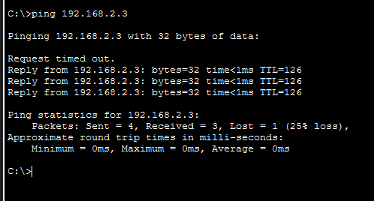
Lab 9

CONCLUSION:

In this lab, RIP Version 2 was configured to enable dynamic routing between two routers. The routers automatically exchanged routing information and updated their routing tables without requiring manual static routes. After the configuration, devices on different networks communicated successfully, demonstrating the efficiency and simplicity of RIP Version 2 for dynamic routing in small networks.

Lab 10

Procedure:
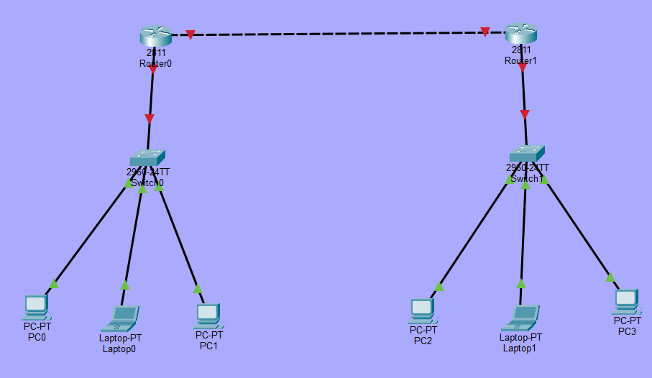

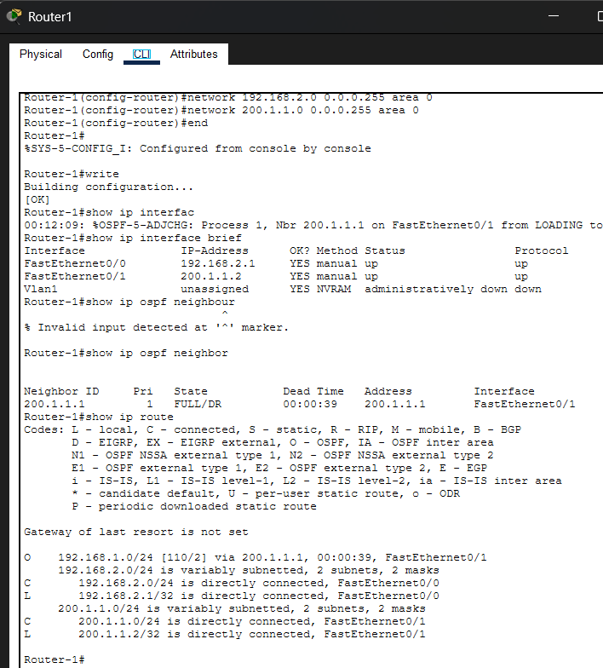
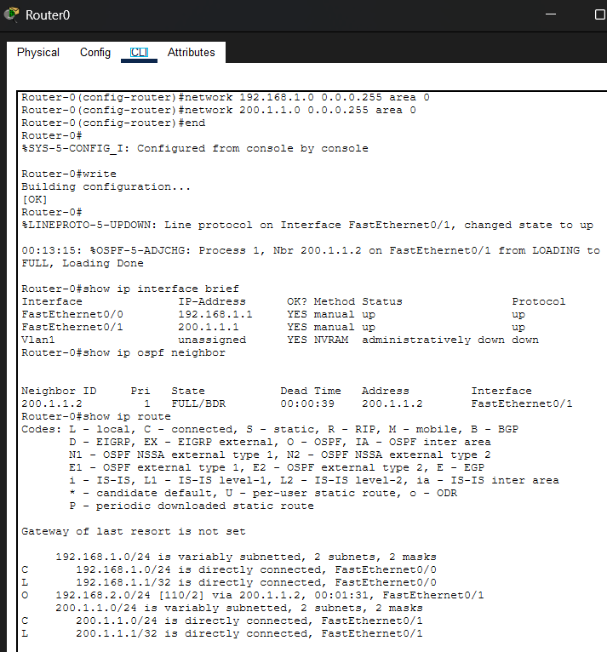

Lab 10
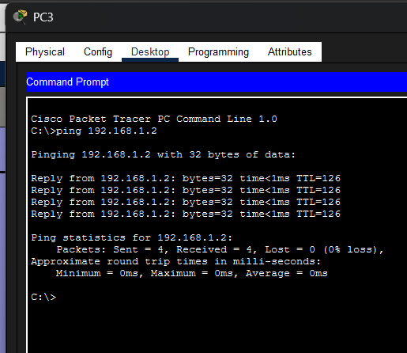
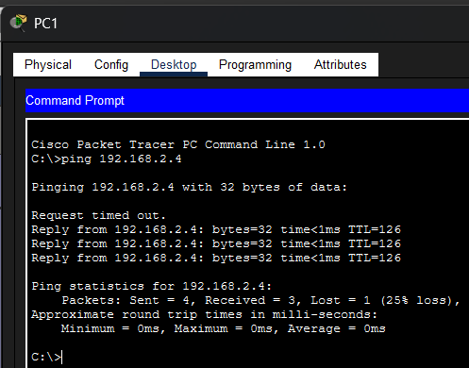

CONCLUSION:

In this lab, OSPF was configured as the dynamic routing protocol to enable communication between two different LANs. DHCP services were also configured on both routers, allowing connected PCs to obtain IP addresses automatically. The routing tables confirmed that remote networks were learned through OSPF, and successful ping tests verified end-to-end connectivity. This lab demonstrated the advantages of combining OSPF's fast and efficient routing with DHCP's automatic IP address allocation for reliable and scalable network management.

Lab 11

Procedure:
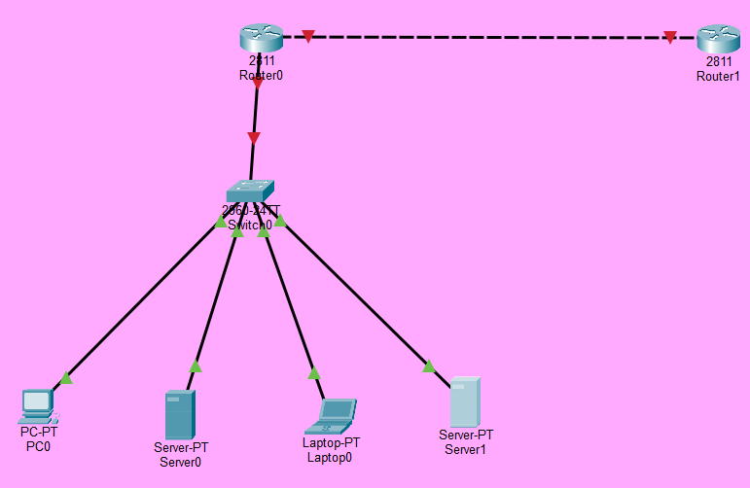
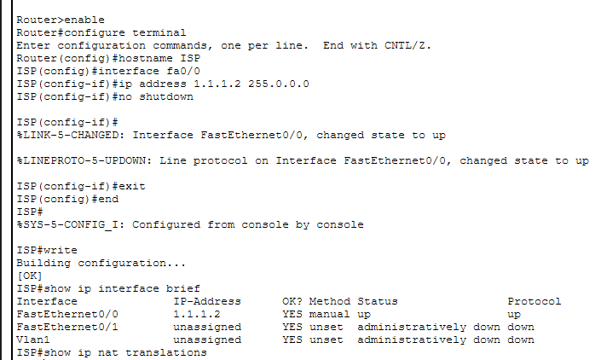
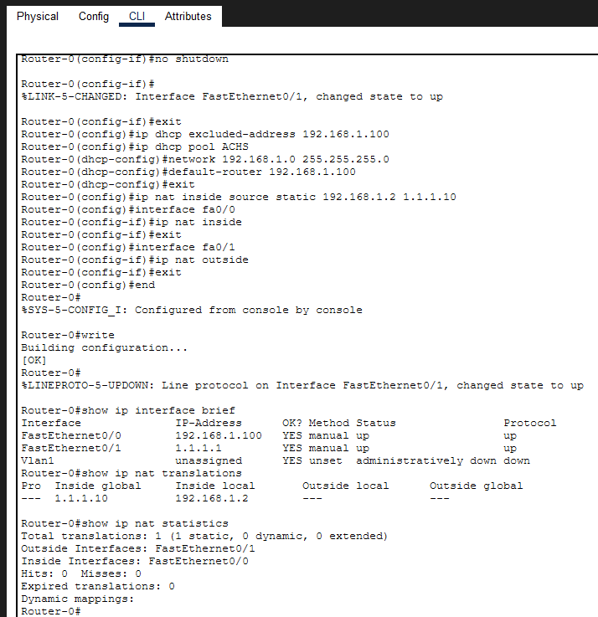

Lab 11
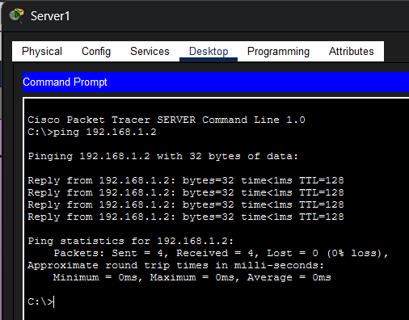
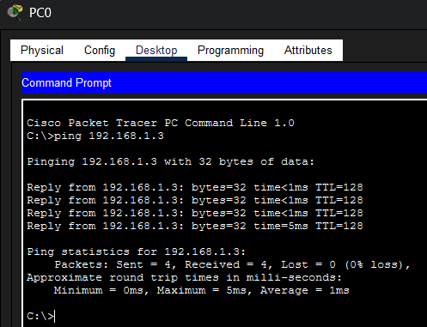

CONCLUSION:

In this lab, Static NAT was successfully configured on a Cisco router to provide a permanent one-to-one mapping between a private IP address and a public IP address. DHCP was used to automatically assign IP addresses to internal hosts, reducing manual configuration. The NAT configuration was verified using show ip nat translations and show ip nat statistics, and successful connectivity confirmed that the internal network could communicate with the external network through the translated public address.

Lab 3

- Apparatus/Tools/Equipment/Components:

- Crimping Tool
- RJ-45 Connector
- Cable Tester
- Twisted Pair Cable
- Principle
Standard Cabling:
- 10BaseT and 100BaseT are most common mode of LAN. You can use UTP category 6 cable for both modes.
- A straight cable is used to connect a computer to a hub.

Cross Cabling:
A cross cable is used to connect 2 computers directly (with ONLY the UTP cable). It is also used then you connect 2 hubs with a normal port on both hubs.

Procedure:

Cable Crimping steps:
- Remove the outmost vinyl shield for 12mm at one end of the cable (we call this side A-
side).
- Arrange the metal wires in parallel
- Make the other side of the cable (we call this side B-side) in the same way.
- After you make it, you don't need to take care of the direction of the cable.

Testing the crimped cable using a cable tester:

- Skin off the cable jacket 3.0 cm long cable stripper up to cable.
- Untwist each pair and straighten each wire 190 0 1.5 cm long.
- Cut all the wires.
- Insert the wires into the RJ45 connector right white orange left brown the pins facing up.
- Place the connector into a crimping tool, and squeeze hard so that the handle reaches its full swing.
- Use a cable tester to test for proper continuity.

File sharing using Ethernet cable:

Step 1: Connect two PCs with the Ethernet cable.

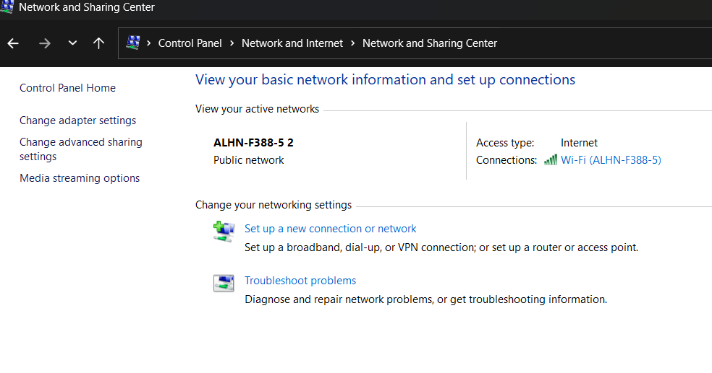
- Right-click the Start button and choose "Control Panel > Network and Sharing Center". You will see the active network or Ethernet.

- Click "Ethernet > Properties > Internet Protocol Version 4 (TCP/IPv4) > Properties".
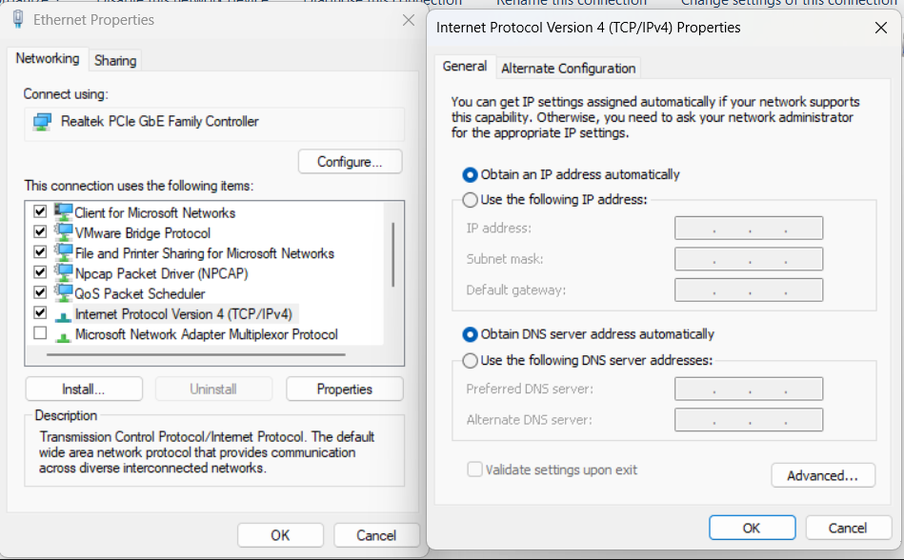

- Select "Use the following IP address" and type the IP address and subnet mask as shown in the screenshot below. The IP you enter differs from the example as long as they are in the same range.

Step 2. Turn on the sharing option on both PCs.

- Go to "Control Panel > Network and Internet > Network and Sharing Center > Change advanced sharing settings".
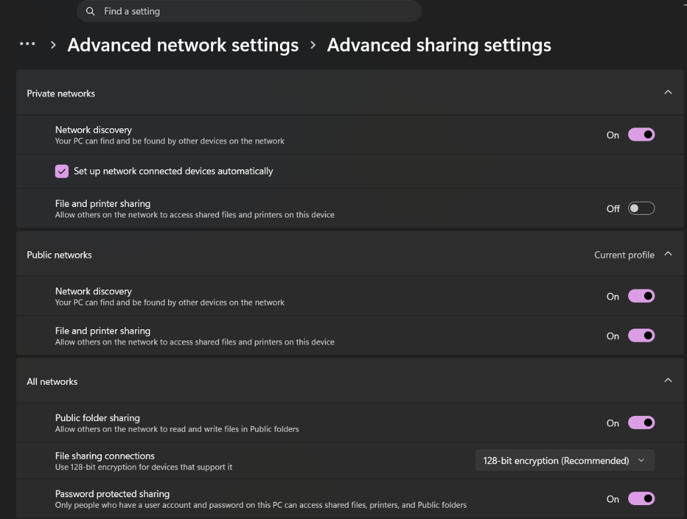

- Choose these options and click "Save changes".
- Turn on network discovery.
- Turn on file and printer sharing.
- Turn on sharing so anyone with network access can read and write files in the public folders.
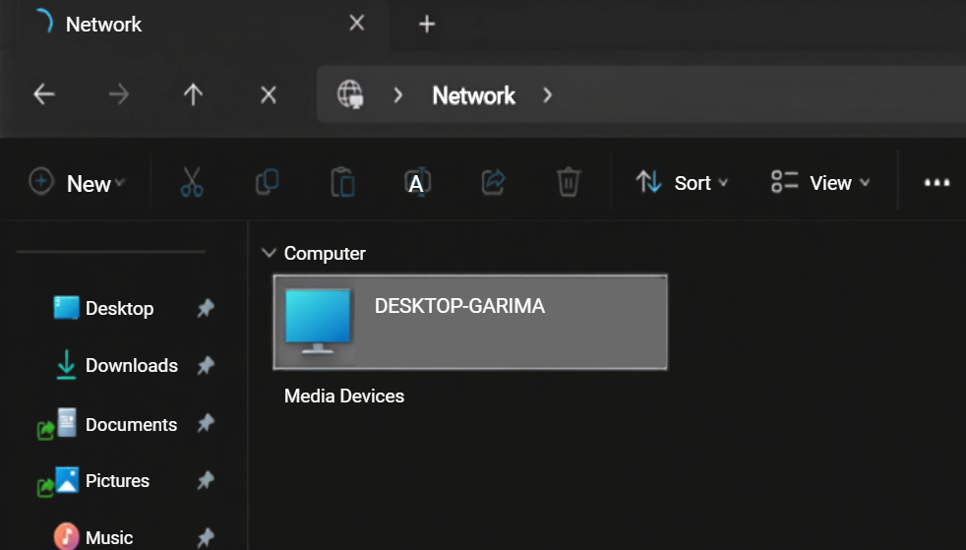

Step 3: Transfer files from one PC to another via Ethernet cable.

- Select the file or folder you want to transfer, right-click it and click "Share with >specific people".
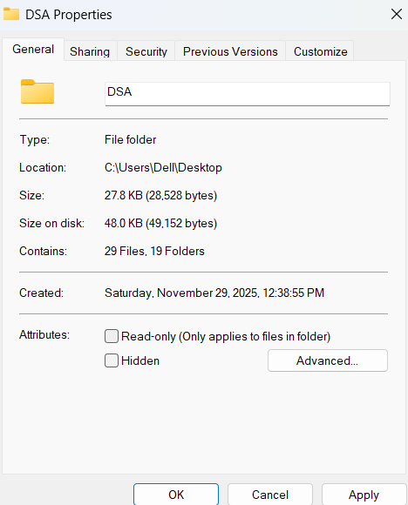
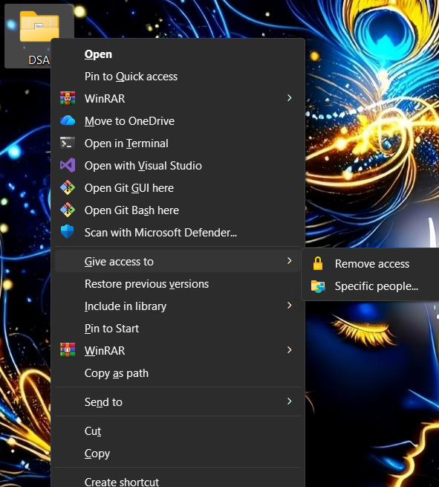
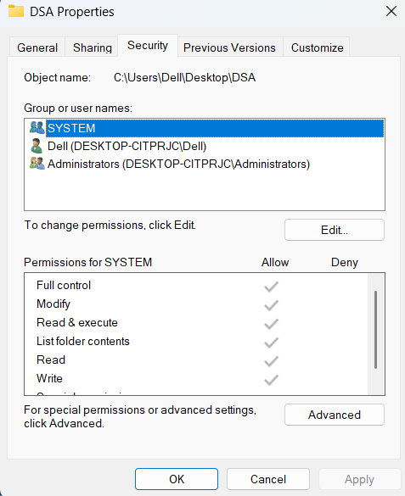
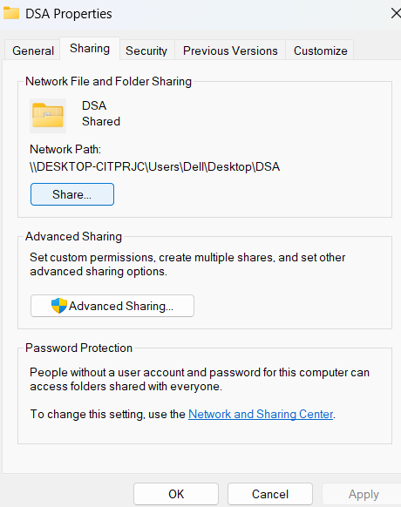

- On the File Sharing window, click the drop-down menu and select "Everyone > Add> Share". Then, the file will be transferred from one PC to another. You can check the shared files on the target PC.
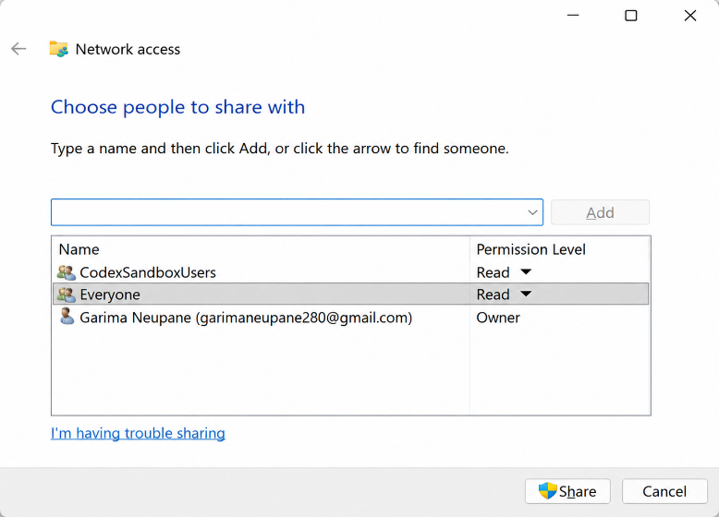
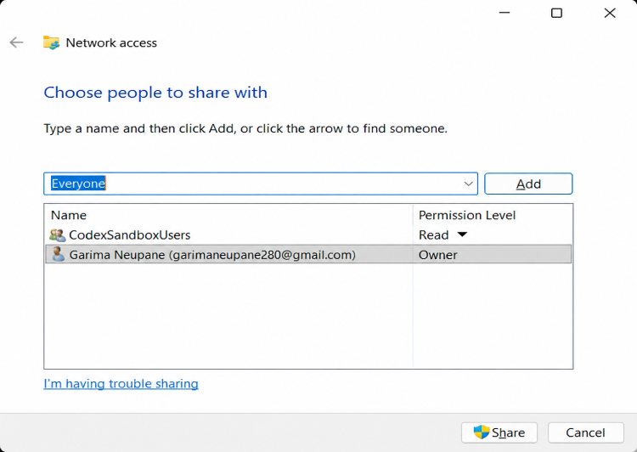

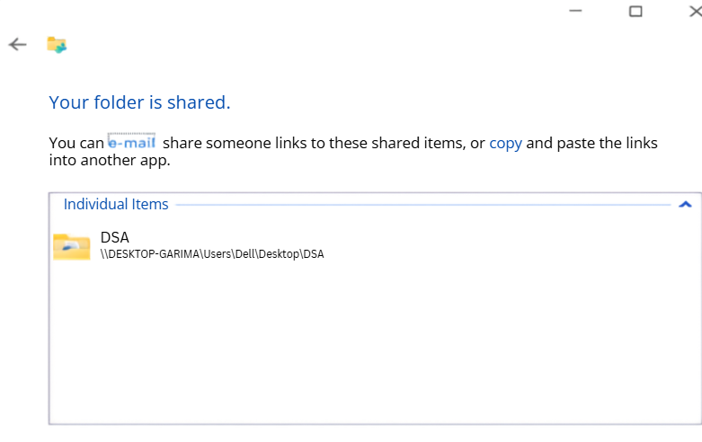

Target PC file:
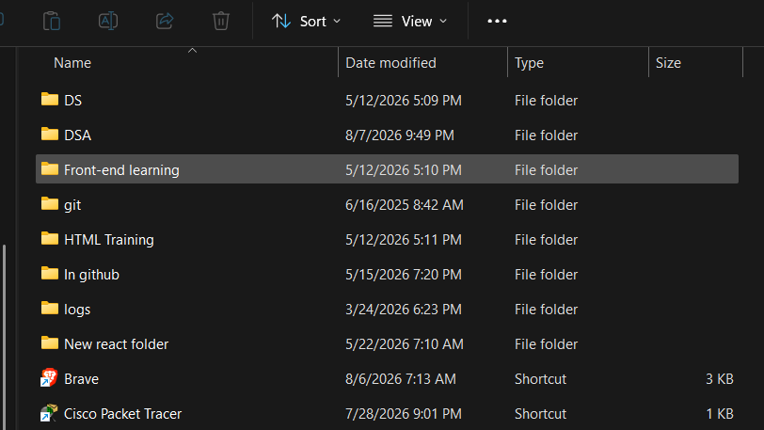

- Conclusion:
The objectives of this experiment were successfully achieved. We learned how to identify Ethernet cable standards and performed cable crimping for both straight-through (standard) and cross-over cables using RJ-45 connectors and a crimping tool. The crimped cables were tested with a cable tester, which verified proper continuity and correct pin-to-pin connections. Finally, two computers were connected using an Ethernet cable, assigned IP addresses in the same network, and configured for file sharing. The successful transfer of files confirmed that the network connection was functioning correctly. This experiment provided practical knowledge of network cable preparation, testing, and basic peer-to-peer communication, which are essential skills in computer networking.

